# GTRX Application User Documentation

## Technology Overview

GTRX is a lightweight self-contained web application build using JavaScript, HTML and CSS. Additionally, Google’s Material Design Framework (http://materializecss.com/) is used for theming and UX. The APP processes the information send by the application backend in JSON format using proprietary Rancho Templates Framework System. The App is hosted on a docker container. [THE BACKEND PROCESSES EXCEL FILES GENERATED FROM ….]

# Functionality

By default, on the first load the APP displays a consent modal popup.

### Index and Search Pages

**Conditions List**

Once the user consents, a full list of conditions is displayed. Each condition is a link to an individual condition page. The list is filterable (see the searchbox above the list) so a user can narrow down the list by any substring in condition title.

Additionally, the app header (repeated on every page), provides the user with a way of searching for conditions, as well as returning to the list of conditions, or switching to a list of genes.

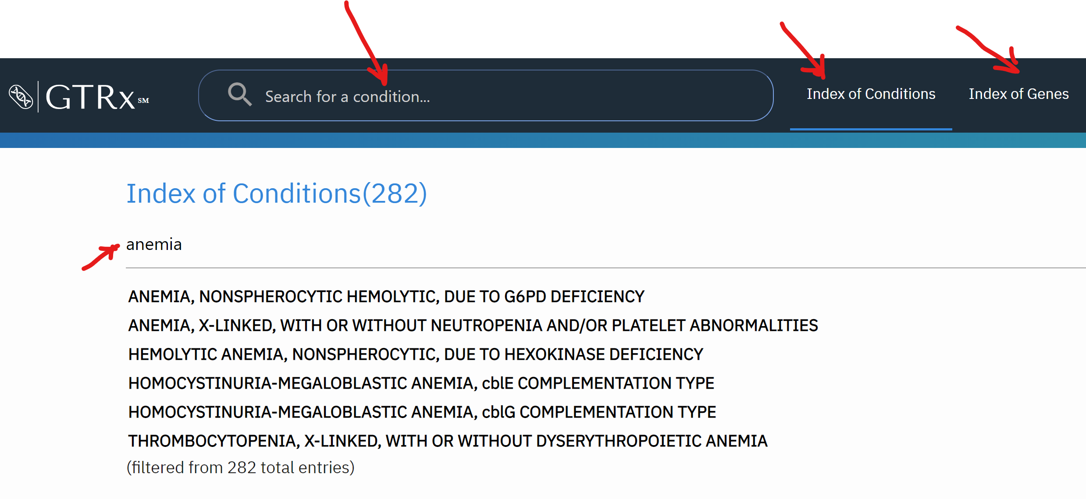

**Genes List**

The genes list is similar to list of conditions in structure and function.

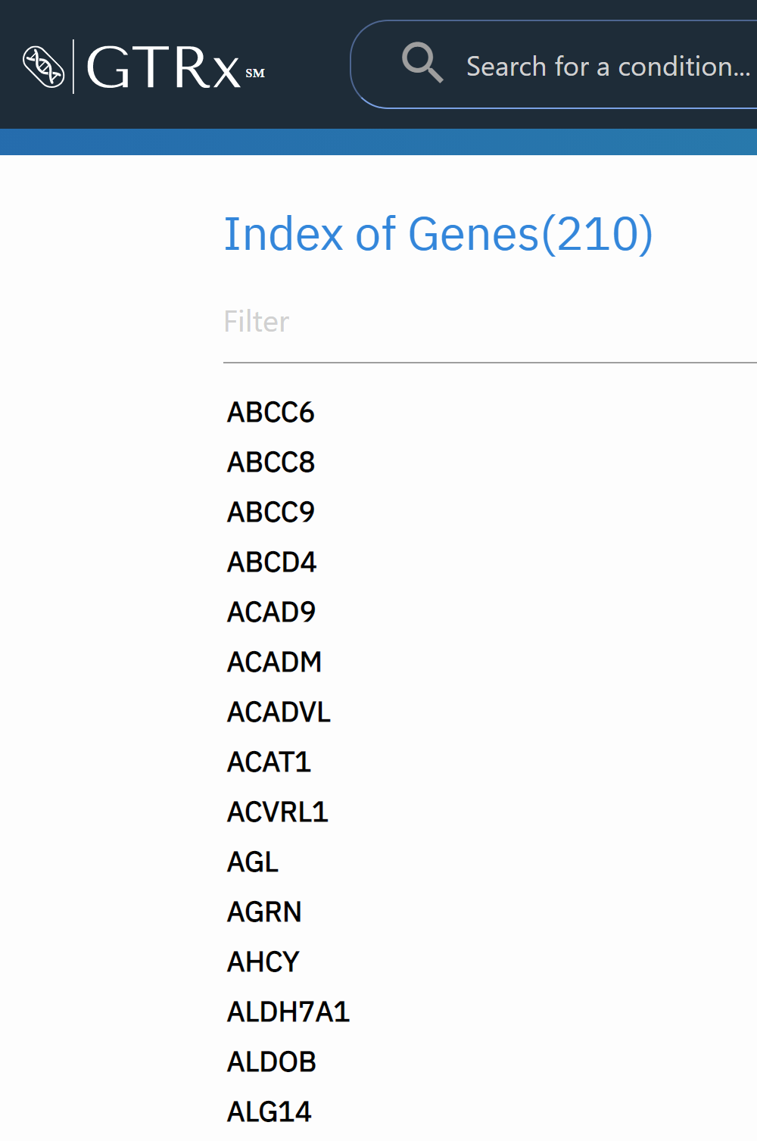

Each entry in the list is a link to an individual Gene page.

### Individual Pages

**Individual Gene Page**

Individual gene page contains general information about the Gene as well as a list of linked Conditions.

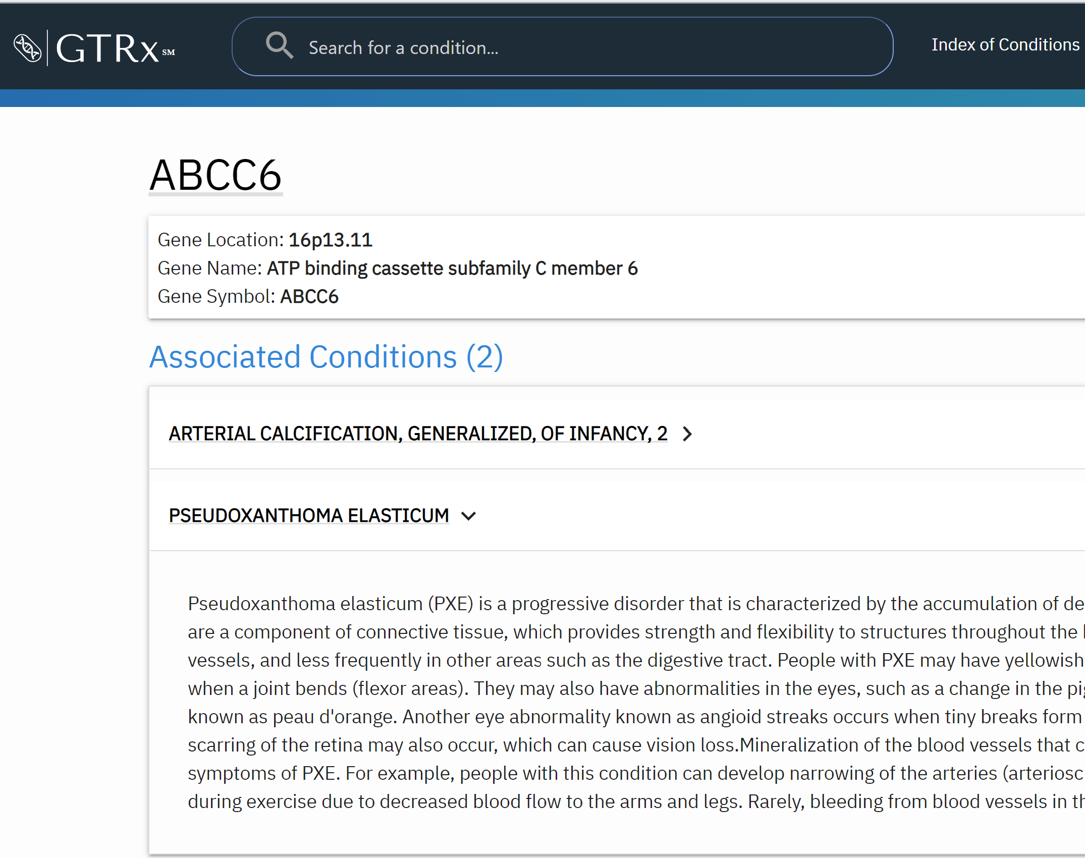

The right arrow expands an “accordion” with the summary for the selected condition. The condition name is a link to an individual condition page.

**Individual Condition Page**

Individual Condition Page is the primary page of the application.

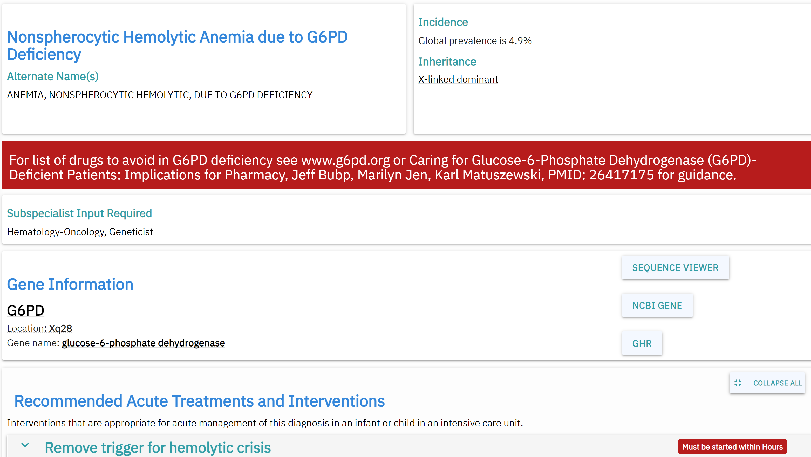

The page is structured in the following sections:

* Condition Name Box
* Incidence Box
* Subspecialist Box
* Gene Information
* Treatments Recommended Box
* Clinical Summary
* List of References (publications) for the condition
* HPO Terms for the condition

The conditions page is guided by the internal navigation that lets the user jump directly to the box of interest.

Additionally, and external links navigation is located in the upper right corner. Both internal and external navigation menus are “sticky” (so they stay when the page gets scrolled). The menus can be minimized by using “hide” button attached to each menu.

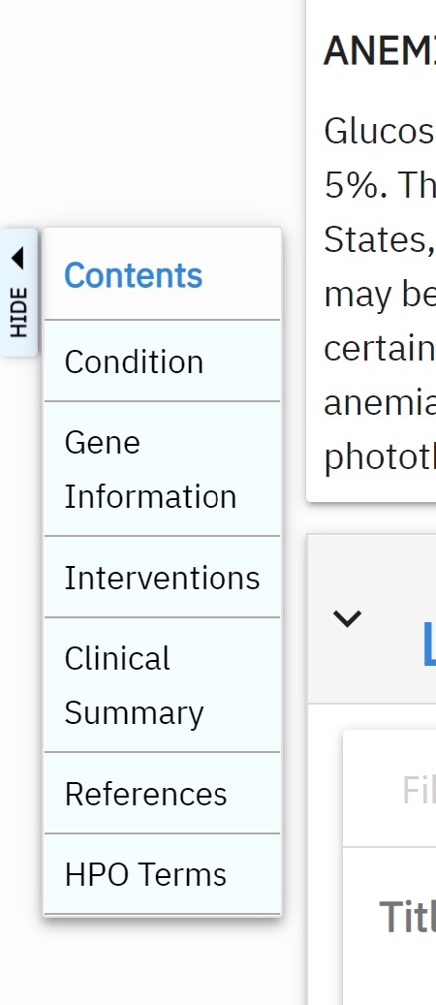 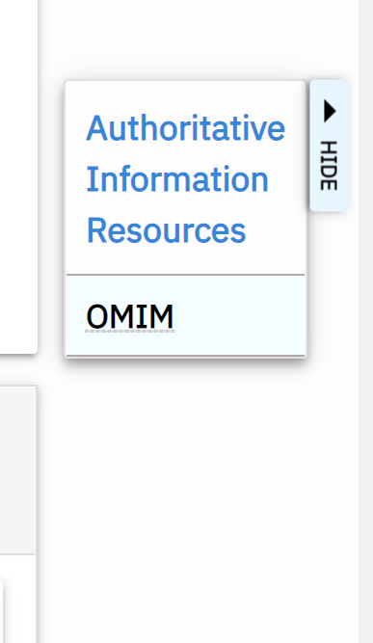

Boxes on the condition page are placed in accodions, so they can be expanded or collapsed:

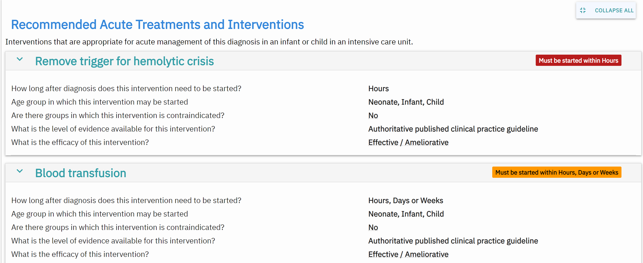

### About GTRX page

About GTRX page contains general, legal and further information, as well as a way to contact the GTRX team.

